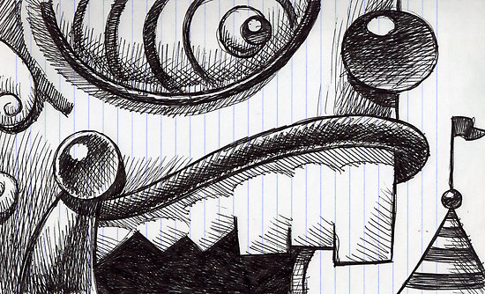
Value The element of Value
What is Value?
- Value describes the lightness or darkness of a color.
- Value is needed to express Volume
- The appearance of lights and darks found in a work of art.
- These range from black to white with numerous shades of gray in between.
Pencils?
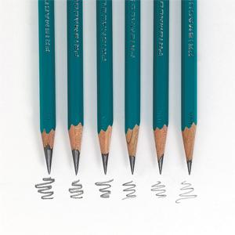
- Pencils come in
  - 6B, 4B, 2B, B, HB, H, 2H, 4H, 6H
- B=Soft Lead,
  - Darks
  - 6B Darker than 2B
- HB= your number 2 pencil
- H= Hard Lead
  - Lights
  - 2H lighter than 6H

Chiaroscuro
The term is derived from the Italian chiaro ("light” or “bright”) and oscuro ("dark") it generally refers to a technique that contrasts bright illumination with areas of dense shadow.

