Photography in the Expanded Field: Painting, Performance, and the Neo-Avant-Garde
Around 1960, more and more photography began to seep across the well-maintained borders separating the mediums of art. While the painters of the Abstract Expressionist movement admired the graphic flair of Aaron Siskind's graffiti details and the sidewalk ballet of Rudy Burckhardt's street pictures, photography was still too irrevocably tied to the mundane to compete with the heroic aspirations inherent to abstract painting. As theorized by the period's most prominent art critic, Clement Greenberg, painting was above all about its very remove from the world to which photography was indexically bound—a painting was good to the extent that it dealt exclusively with problems and issues related to its own specific qualities as a flat, bounded surface on which marks were made.

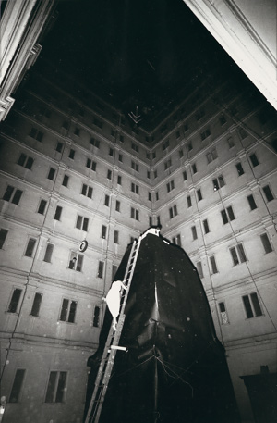
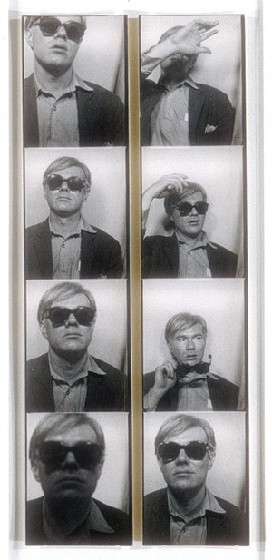
At the same time that Abstract Expressionism began to wane, however, a disparate group of artists began to explore some of the overlooked implications of action painting—its gestural freedom, chance effects, and urban themes—giving birth to a wide array of strategies epitomized by Robert Rauschenberg's oft-quoted statement that he wanted to act in the gap between art and life. Rauschenberg himself had been making Combines—found objects covered with slashing strokes of paint that blurred the boundaries between high and low—since the mid-1950s, and in the early '60s began transferring photographic images from newspapers directly onto his canvases (via the process of silkscreening) in rebus-like arrangements. In this neo-avant-garde work, artists such as Rauschenberg adapted the shock tactics of World War I-era Dada collagists such as Kurt Schwitters to the new postwar context of American hegemonic power.
Unsurprisingly, some of Rauschenberg's paintings were created as set designs for modern dance, and the early 1960s also witnessed an explosion in performance, experimental theater and film in which photography played a crucial role. Perhaps the quintessential expression of this ferment were the new non-narrative, participatory performance pieces described by Allan Kaprow (2002.334,335,336) as "happenings"—anarchic events intended to break through the complacency and conformity of mainstream American life and described by Susan Sontag at the time as "animated collages." Trained as a painter, Kaprow intuited an expanded scale and space from the work of Jackson Pollock. He also studied composition at the New School for Social Research in New York with John Cage (a close friend of Rauschenberg), whose use of nonmusical and ambient sounds as well as his openness to chance and accident made him a key figure of influence during this period. Kaprow described the dynamic images made of happenings by photographers such as Lawrence Shustak and John Cohen (1997.503.1) as "dreamings"—companion visions that qualified them as independent works of art in their own right.
Another artist who silkscreened photographs across his canvases was Andy Warhol, who serially repeated gruesome tabloid pictures of anonymous death and disasters along with vapid promotional stills of movie stars in order to replicate the numbing effects and loss of affect that accompanied the rampant expansion of media and technology into every corner of life. Another photographic aspect found in Warhol's early paintings was his use of the automated "four-for-a-quarter" photo-booth of the kind found in the pleasure centers of urban spaces such as Times Square or Coney Island. While still working as a commercial artist, Warhol became obsessed with this popular, ubiquitous device, and asked friends and portrait sitters to sit for their pictures in order to use the results as the foundation for large silkscreen paintings, magazine illustrations, and album covers. For Warhol, photography—mechanical, reproducible, and indelibly tainted with mass culture and industrial production—served to question the cherished notions of authenticity and originality that underlay Abstract Expressionism.
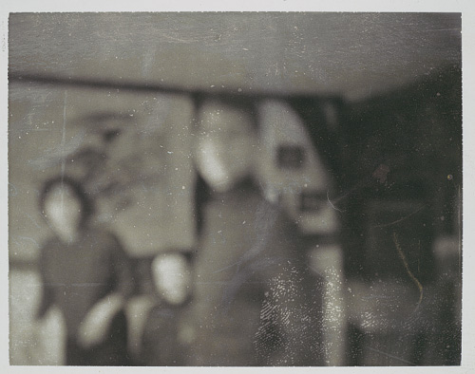
In Germany, Gerhard Richter (2003.234) began compiling his own private, vernacular photographic atlas of the world: amateur and family photographs he found and collected; news images of political and historical events; advertisements and pornography; even shots of the Nazi death camps. This massive accumulation then became a source of predigested, precomposed imagery from which the painter made his famously blurred photo-paintings. In 1964, Richter described the function of vernacular photography in his working process: "Stags, aircraft, kings, secretaries. Not having to invent anything anymore, forgetting everything you meant by painting—color, composition, space—and all the things you previously knew and thought. Suddenly none of this was a prior necessity for art."
Douglas Eklund
Department of Photographs, The Metropolitan Museum of Art

Name: Block:

Photography in the Expanded Field: Painting, Performance, and the Neo-Avant-Garde
Please use complete sentences when you fill in the main idea and supporting details.

