Magazine Cover or Page Layout
Photojournalism = Text
Starting off:
- Googling Magazine Covers and Magazine Layouts
- Find a Tutorial on Text or Magazine design or Begin to design on Photoshop
  - http://speckyboy.com/2009/02/25/28-incredible-photoshop-image-manipulation-techniques-and-tutorials/
  - http://www.photoshopwebsite.com/photoshop-tutorials/30-top-photoshop-cover-design-photoshop-tutorial/
Photo 1:
Create a canvas size or crop a picture to H- 11 inches x W. 8.5 inches
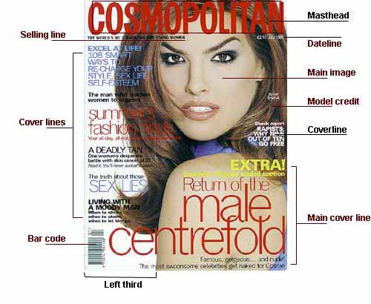
What you need:
- Main Title
- At least 3-4 subtitles/headings
- Barcode
- Date
- Issue Number
- 1 main picture
- Can add other smaller pictures

Studio Photo:
Create a canvas size of H- 11 inches x W. 17 inches

What you need:
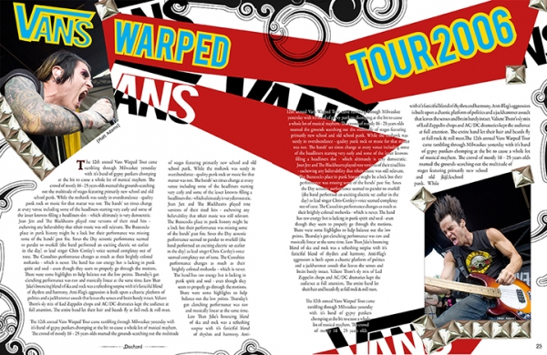
- Main Title of Article
- 1-2 Subtitles or quotes
- Article words (paragraphs)
- Date
- Author Name
- Page Number
- 1 Main picture
- Can add other smaller pictures

Graded on
- Clarity 20
- Following Directions 20
- Creativity 20
- Overall affect 40 100 points TOTAL!

