History of Photography…
Photography:
- Comes from the greek words __________ for photo and ___________ for graph
- This Translates to“______________”
- Early photographs were called ___________ pictures, because sunlight itself was used to create the image
- Today, photography has become a _________________________________
Camera Obscura:
- The camera obscura had been known since ancient times. It was first detailed in writing by artist and inventor ___________.
- Meaning literally " ___________ ___________," it was originally a room completely sealed from light except for a very small hole in one wall.
- Later became the ___________
1826 First Permanent Image:
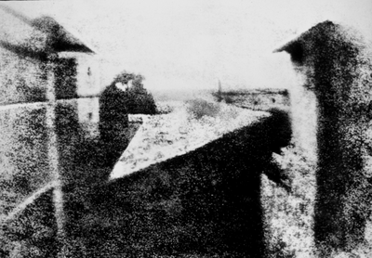
- French inventor ___________uses a ___________to burn a permanent image of the countryside at his Le Gras, France, estate onto a chemical-coated pewter plate.
- He names his technique " ___________," meaning "sun drawing."
- The black-and-white exposure takes ___________ hours and fades significantly, but an image is still visible on the plate today.
1839: First Photo of a Person
- In early 1839, French painter and chemist ___________ ___________ photographs a Paris street scene from his apartment window using a camera obscura and his newly invented ___________ ___________.
- The long exposure time (several minutes) means moving objects like ___________ and ___________ don't appear in the photo.
- But an unidentified man who stops for a shoeshine remains still long enough to unwittingly become the first person ever photographed. 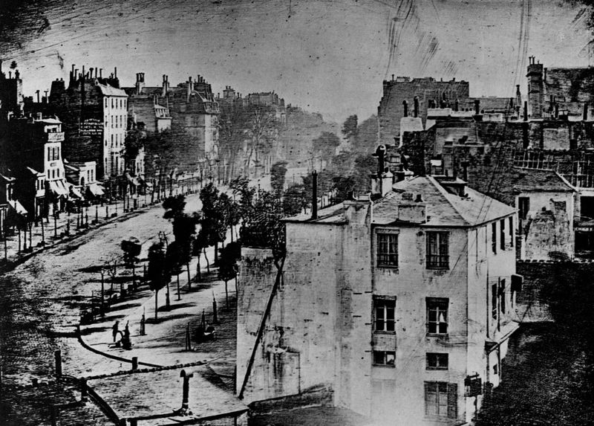
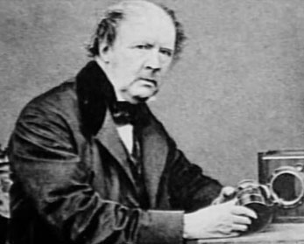
1839: First Negatives
- Talbot-In England ___________had developed his own method of photography at about the same time that Daguerre was inventing the daguerreotype.
- Essential he created the first working negative.
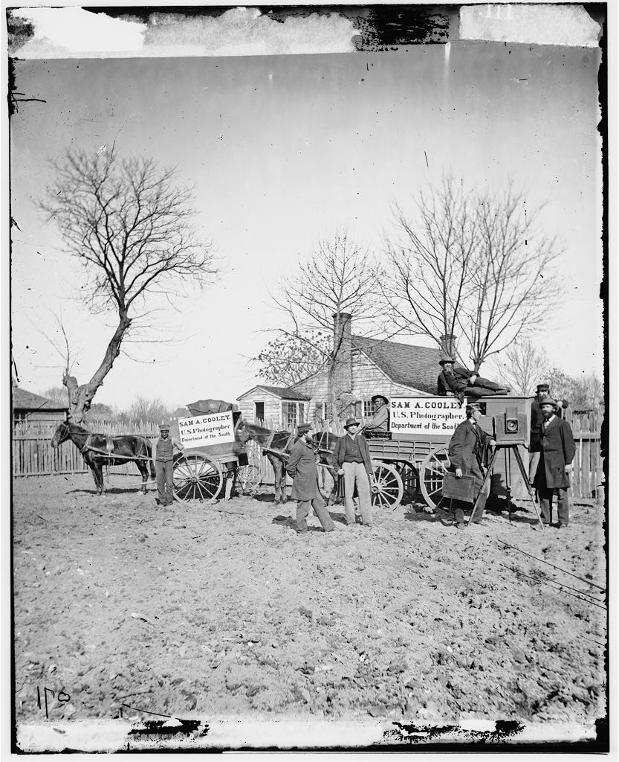
- One negative= ______________________.
1851: Archer
- In 1851 ______________________of England made public his ___________process, in which he used a glass plate coated with collodion as a base for light-sensitive silver halides.
- Created the portable ___________ ___________.

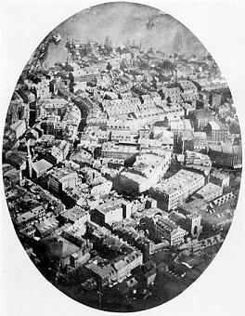
1858: First Bird's-Eye View
- ___________, better known by the nom de plume Nadar, combines his interests— aeronautics, journalism, and photography— and becomes the first to capture an aerial photograph in a tethered ___________ over Paris in 1858.

1861: First Color Photo
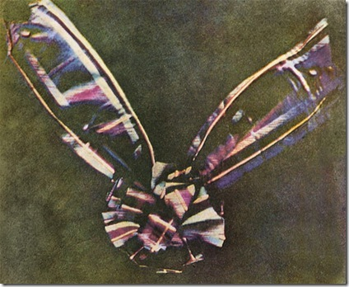
- The enormously influential Scottish physicist ___________ ___________ creates a rudimentary color image by superimposing onto a single screen three black-and-white images each passed through three filters—________,___________, and ___________.
- His photo of a multicolored ribbon is the first to prove the efficacy of the three-color method, until then just a theory, and sets the stage for further color innovation, particularly by the Lumißre brothers in ___________.
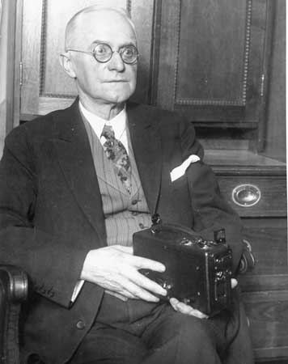
1880’s- Kodak
- In the 1880s the American ___________put ______________________on the market, and in 1889 he introduced the first Kodak camera with the slogan,
- "__________________ ______________ _______________________."
- Thus was launched the era of ___________ ___________.
1930’s= Flash bulbs
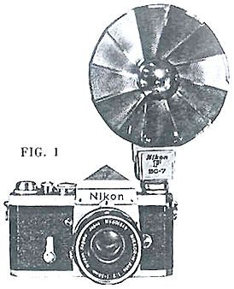
- In 1930 the highly dangerous flash powder was largely supplanted by ___________.
- At the Massachusetts Institute of Technology, experiments with gas discharge flash tubes led to the development of the electronic flash, which could produce astonishing images made at exposures as brief as ___________second.
- Although they originally required expensive and cumbersome equipment, electronic flash units became so miniaturized that they could be built into a ___________ ___________.
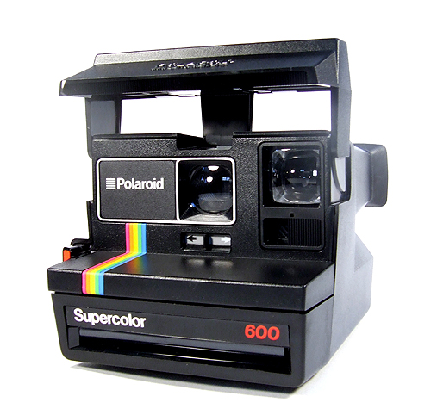
1963- Polariod
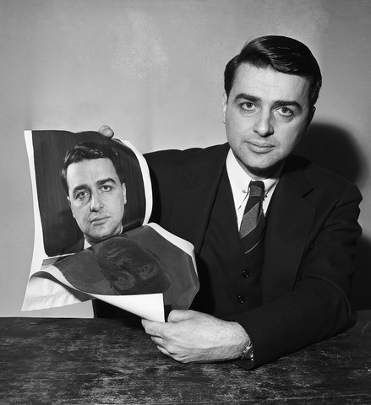
- Today ___________ ___________ ___________constitutes the vast majority of film sold to amateur photographers in the United States.
- Instant, or self-processing, photography was invented by the American ___________.
- He introduced the Polaroid Land camera in ___________, and a color version became available in ___________.
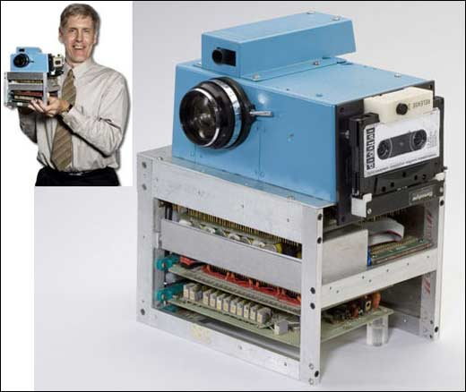
Digital Area
- 1984
Canon demonstrates first digital ___________ ___________.
- 1985
___________ introduces digital imaging processor.
- 1990
Eastman Kodak announces ___________as a digital image storage medium.
- 2009 Kodak announces the end of making ___________ ___________.
Everything going digital….
Time Line

