Darkroom Techniques:

Dodging and Burning
There are various techniques that can be used in the darkroom to help obtain the perfect image. The techniques known as dodging and burning are essential for film photography developers to learn and understand. In basic terms, dodging is a process to lighten dark spots on a print and burning is a process to darken light spots on a print to achieve a consistent exposure throughout the image. When printing in the darkroom, you may notice areas of the photograph are not consistent with the tones of the image and are too bright or too dark. Commonly, this may include bright skies that appear washed out or dark shadows that show no detail. These are prime examples of how dodging or burning can help to fix these trouble spots.

Dodging
If a spot is too dark and shows little or no detail, then dodging is the option for you. Essentially, you need to block light from that spot for a few seconds during exposure. Remember, less light will give you a lighter exposure, so you can lighten up the dark space to see some more detail. Dodging is done with any object that completely blocks light, although some darkroom experts will use objects with some opacity. The light blocking material should form a similar shape to the trouble spot. Using the tool, block the light from hitting the trouble area for a second or more depending on how much you need to lighten the area. If you simply cover the spot with the tool, an outline of the object will be present on the paper, so it is imperative that you slightly shake the tool to prevent this from happening.

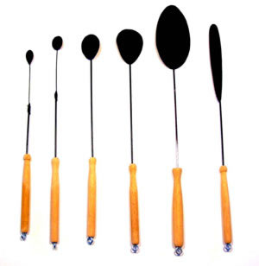
Tools Example 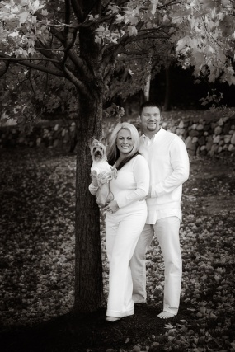

Burning
If a spot on your print is too light, then burning is the correct option. Burning works exactly the same as dodging, just inversely. Burning will add more light to a trouble spot to darken it. To use the burning technique, add additional exposure time for the print. For the duration of the extra time, block everything you do not wish to change so that only the light spot is exposed. The additional exposure time will darken the spot to create a more even tone. Once again, it is imperative that you slightly shake the light blocking tool to prevent any outlines from appearing on your print.
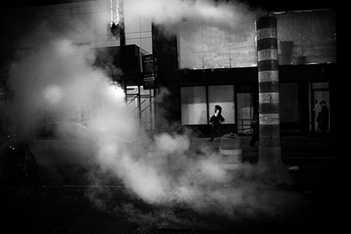

Tool Example

