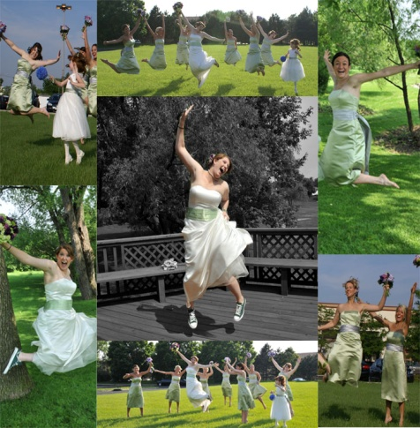
Action Photography
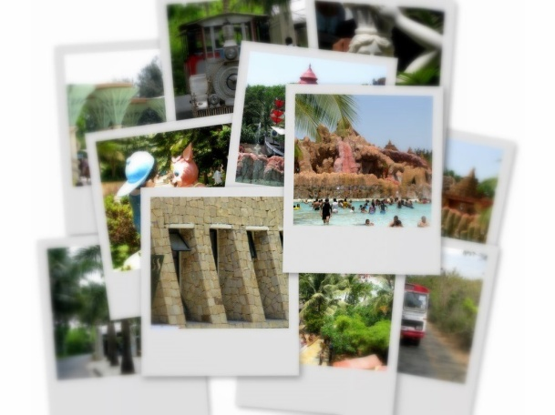
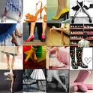
Requirements:
- 5-10 pictures
- One Main Picture
- All images show unity (they belong together)
- All images are enhanced either by filter, adjustment, or manipulation

Tools and terms:
Layers, Free transform, Adjustments, Filters

Basic Steps:
- New >Canvas Size: 10x10 inches
- File >Open> Main or center picture> Crop image to 5x5 inches> Select all with Rectangular Marquee Tool> Copy> Paste in 10 x10 canvas
- To resize image- Edit > Free Transform
- Open New Layer
- Repeat Steps 2-3, Paste on New Layer
- Once all your pictures have been inserted use Image> Adjustments, or the Filter Gallery to enhance images
- To change the back ground color click on the background layer, then the paint bucket tool and color tool bar to select color.
- You may add text

Things to remember:
- Save often and in multiplies place
- The free transform tool can overstretch images which can be misleading
- To move a certain picture you must click on the layer it is on first.
- Be Creative

