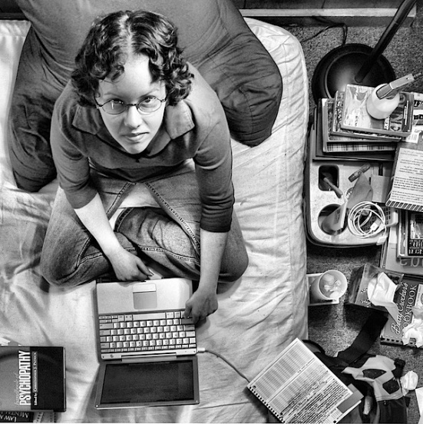
Unusual Perspectives!
Mrs. McArthur- Photography

24 pictures from unusual angles
Worm’s eye view, Bird’s eye, Look up, etc…
- Film: Ilford Delta 400
- Subject matter 80-100%
- No distractions – eliminate distractions
- Rule of thirds
- Shoot outside, look for value changes ( do not shoot indoors unless you have spot lighting)
- Elements and principles…..
- Bracketing will help! At least write down your pictures on a bracketing sheet.

Look at the world in unusual ways!
