Name: Block:

The Structure of Photographic Metaphors
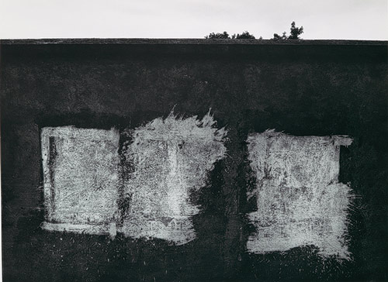
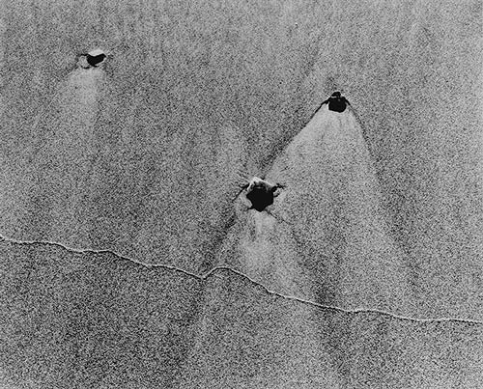
While postwar street photographers on the East Coast were transforming documentary photography into a subjective experience of the contemporary world, photographers in other parts of the country were expanding the f/64 tradition to accommodate their own personal creative spirit. One locus of this activity was Chicago, home of the New Bauhaus established by László Moholy-Nagy in 1937 (the school closed a year later but was reincarnated as the School of Design in 1939, renamed the Institute of Design in 1944, and incorporated into the Illinois Institute of Technology in 1949). In the tradition of the German Bauhaus, which had been closed for political reasons in 1933, the school placed photography at the center of its curriculum on the premise that the photographic medium had introduced a new visual language that was intimately tied to the modern world. Moholy-Nagy wrote in 1936, "The illiterates of the future will be ignorant of the use of camera and pen alike." The school was founded on this idea, but those who taught there expanded upon it in many ways. Harry Callahan began teaching there in 1946, and his approach used photographic forms to elucidate experience. In photographs such as Untitled (triptych) (1996.291a-c), he set up his equipment in one place on the beach and pressed the shutter as seaweed, pebbles, and other beach detritus passed through the frame. His camera's intrusion upon this quiet and viscous moment becomes the cool serenity of the images, underscoring the camera's ability to transform our experience of time. Other photographs, such as Eleanor, Chicago (1988.1161.2), highlight the metamorphosis that occurs when the camera intercepts emotionally charged space and processes it into abstract forms arranged on photographic paper.

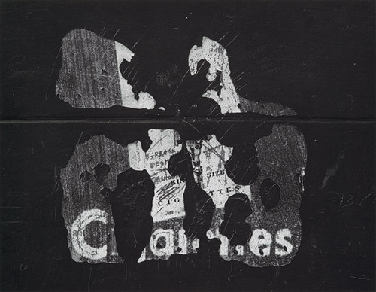
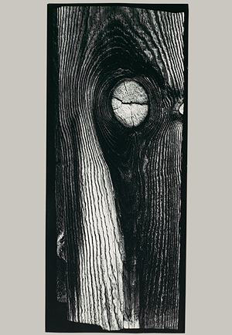
Aaron Siskind, who began teaching at the Institute in 1950 at the invitation of Callahan, found analogues to photography's tonal language in man's impulse to make his mark on the world. He is best known for photographs of walls inscribed with calligraphic markings or tattered signs, as in Uruapan 11 (1991.1215), in which Siskind has noted the blotting-out of the natural world by a concrete wall. In Chicago (1991.1212), the wall is a dark, immutable presence onto which humanity's passing fancies are inscribed. Siskind (who headed the photography program at the Institute of Design from 1961 to 1971) executes them in exquisitely printed, tonally subtle renderings that intertwine the literal and symbolic goals of the Institute's photographic principles. One of Siskind's and Callahan's most well-known students was Ray K. Metzker (1990.1083), who translated the formal tenets of his mentors into a design vocabulary that reinvigorated the medium during the Pop era by investigating the photographic image's role in the visual-cultural code of contemporary life.
Another related, but more mystical, school of thought in photography centered on the work of Minor White, whose early flirtations with documentary photography combined with his spiritual quest to produce work with a profound, metaphorical resonance. In early works, such as Nude, Portland, Oregon (1987.1100.498), White made the formal beauty of the body palpable, lending a sense of calm to the charged materiality of the subject. After World War II, White devoted his career to the concept of the sequence, which for him provided the best opportunity for the voice of the photographer to emerge: "With single images I am basically an observer, passive to what is before me, no matter how perceptive or how fast my emotions boil. In putting images together I become active, and the excitement is of another order—synthesis overshadows analysis. The poet says, 'The line is given, the rest is up to me.' Adapting this to photography, it reads, 'When the images are given, sequencing is up to me.'" In White's sequences, every photograph is meant to be individually appreciated as well as felt within its sequence. This made the last photograph in a sequence, like the one from Sequence 1967 (1995.563), bear a tremendous amount of weight, but the strength of White's work bore it gracefully.
Also striking an independent note in American photography during the postwar period was Ralph Eugene Meatyard (67.543.29), whose compelling amalgamation of formal balance and unusual subject matter made his work instantly unforgettable. He photographed what seem at first to be familiar scenes in a normal, rural environment, but with a few peculiar elements inserted throughout—a creepy Halloween mask on a child's face; a tattered, distressed-looking doll; a bird carcass hung on the wall, etc. The result leaves the viewer with an eerie sensation that pricks at his or her faith in the banality of normal life. Both White and Meatyard, although not directly connected otherwise, initiated photography's metaphysical estrangement from the material world during the postwar era, carving out a space for the medium in contemporary art that continues to be inhabited today.
Lisa Hostetler
Department of Photographs, The Metropolitan Museum of Art

Name: Block:

The Structure of Photographic Metaphors

