Photography Final Collage Project
Due: Thursday 5/20 end of class
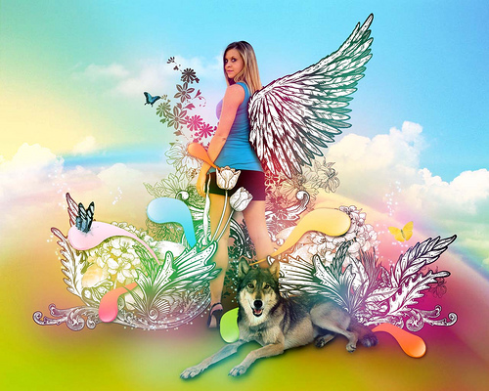
Needs to Include:
- 1 picture of yourself
- 6 pictures taken by you that represent you.
- At least one line of Text
- Colors need to be altered in some way
- 4 filters used
- Canvas Size 8.5 x 11 or 11 x 8.5 inches
- If you want find a tutorial to help you start…

Rubric 100 points
7 Images taken by you 40 points
Interesting Unique Composition 20 points
Easy to read 20 points
Follow Directions 10 points
Prepared for class 10 points



