Photography and Everyday Life in America, 1945–60

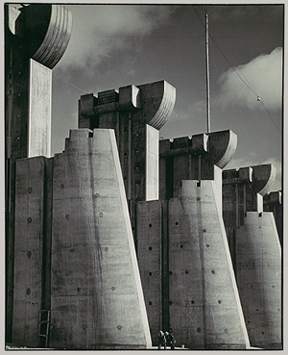
"A photograph is not merely a substitute for a glance. It is a sharpened vision. It is the revelation of new and important facts." This sentiment, expressed by the Photo League photographer Sid Grossman (1990.1139.1), encapsulates photography's role in America in the 1940s and '50s. The era saw the apotheosis of photojournalism and few photographers were unaffected by its rise, whether they joined the bandwagon or reacted against it.

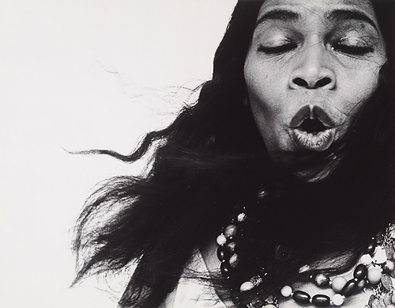
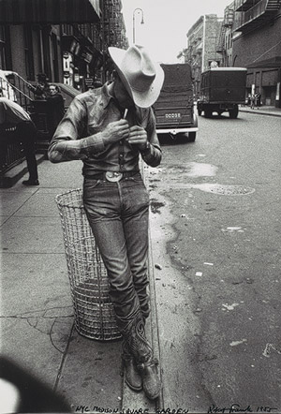
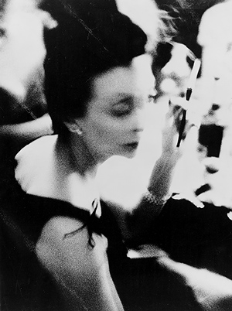
Ushering the age of the image into American culture was Margaret Bourke-White's Fort Peck Dam, Montana (1987.1100.25), which appeared on the cover of the first issue of Life magazine in November 1936. For the next three decades, magazines (Life foremost among them) told the world's news stories through pictures. World War II was the first major widespread conflict covered extensively by photojournalists, who earned reputations as heroes for risking their lives to visualize the events. W. Eugene Smith was perhaps the most famous postwar photographer to earn his stripes on the battlefield, and, after the war, his photo essays—a form that he perfected in stories such as "Country Doctor" (1948), "Spanish Village" (1951), and "A Man of Mercy" (on Albert Schweitzer, 1954)—were as unrelenting as his war photographs, making the viewer experience the world as the subjects did and demanding a sympathetic response. Smith's work created this effect both through individual pictures, and by sequencing the photographs in order to create a sense of narrative through mood. His insistence on producing his own layouts made for a tempestuous relationship with the publications for whom he worked, however, and he joined the Magnum photo collective in 1955 in order to work more freely.
The fast-paced world of the photojournalist invaded photography from the late 1930s through the rest of the century, even finding parallels in the fashion magazine. Art directors such as Vogue's M. H. Agfa and Harper's Bazaar's Alexey Brodovitch (2005.100.295), who emigrated to America just prior to the war, brought the freedom of small-camera photography developed by photojournalists like Felix H. Man and Martin Munkacsi in Europe to the pages of American fashion magazines. They also brought fresh visual concepts directly from the avant-garde in Paris and incorporated those ideas into their graphic designs. Brodovitch was particularly innovative in this regard; not only did he invent a new visual language for the fashion magazine, but he also hired fashion photographers according to new criteria: he wanted to be "astonished" by radical images and was willing to neglect the display of the merchandise, so he evaluated photographers based on their personal work done outside the fashion studio. His bet was that mood was a better seller than description when it came to fashion. Whether their specialty was elegance or attitude, he encouraged photographers like Irving Penn (2002.455.5) and Richard Avedon (61.565.2) to mine their imagination for new images, regardless of whether their interests seemed directly related to fashion. It was principles like these that allowed artists to pursue their own work without compromising their artistic integrity. Two of his most successful protégés made some of their best photographic art during the years they were primarily engaged in fashion photography: Penn made voluptuous nudes and Avedon devoted himself to making stark portraits of cultural figures that interested him.
In the years around World War II, other photographers transcribed documentary photography and photojournalism into personal statements inspired by contemporary social life. Some of them were associated with the Photo League, an organization founded in 1936 when Sid Grossman (1990.1139.1) and Sol Libsohn broke away from the Film and Photo League to form an organization dedicated to documentary photography and social change. During the McCarthy era, the group increasingly distanced itself from politically sensitive subjects, moving from the model of Lewis Hine to that of Helen Levitt (1996.2.1) and Lisette Model (1988.1029), before its dissolution in 1951. Working outside the Photo League were photographers like Louis Faurer (1987.1055)—whose focus on the outcasts and marginal elements of urban life became both a projection of his own complicated experience of the city and a dissenting voice in the increasingly conformist culture of postwar America—and William Klein (1989.1038.2), whose aggressive, hard-hitting photographic style mimicked New York's defiant heterogeneity. The culmination of the period was Robert Frank's photographs in The Americans (such as Rodeo [1992.5162.3]) and from the late 1950s (such as Fourth of July, Coney Island [2002.273]), which penetrated the country's sunny facade to discover a newly powerful yet vulnerable nation overwhelmed by its own importance and struggling with internal strife.
Lisa Hostetler
Department of Photographs, The Metropolitan Museum of Art

Name: Block:

Photography and Everyday Life in America, 1945–60
Please Complete the Graphic Organizer below using complete sentences. (no bullet points!)

