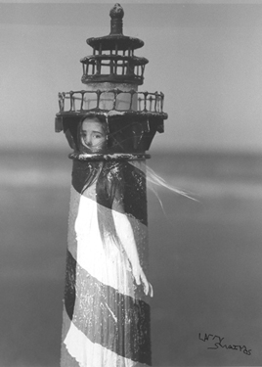Photo Manipulation

Dark room

Objective: for this project you will learn the old darkroom techniques to manipulate photographs as well as the Photoshop techniques.

In the Darkroom:

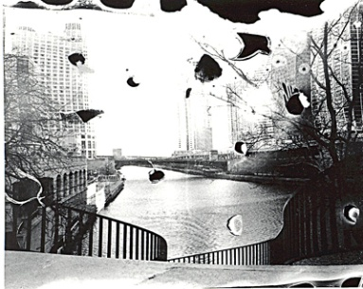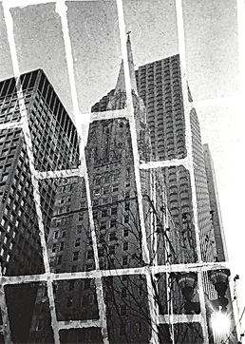You will be using household items to transform the way your photographs turn out. By placing a piece of glass over your photo paper you can easily change your image without bother the chemical make-up of your paper.

Some fun things to try are:

* Sugar
* Bubbles
* Plastic Wrap
* Lace
* Creating a double negative by placing one negative over another.
* Burn the negative.
* Bend or fold the negative.
* Cut and tape the negative back together with clear tape.

\* Hint! Items that are semi transparent create amazing effects!

What you will be turning in for the Dark Room Portion:

1. 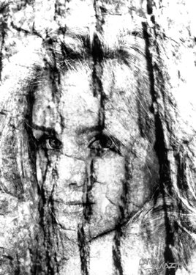Test Print
2. Contact Sheet
3. 2 of the same print but manipulated differently
   * Size (5x7 or 5x4 )
   * Matted together using the Mat Cutter.

Things to Remember:

* Quality of the prints is most of your grade! Must have Strong Contrast!
* Grading will become more difficult because we are more then half way through the semester.
* Think outside the box.
* Doing average work will earn you a C. Go Beyond!