Camera Parts mrs. mcarthur

release button locking bush
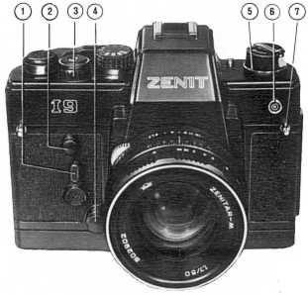
neck strap eyelet
depth-of-field preview button
film rewind knob
self-timer release button
flash unit connector socket
self-timer lever
shutter cocking and film advance lever
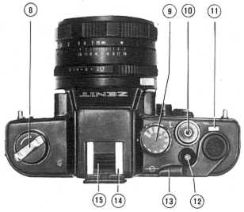
film rewind crank
release button internally threaded for cable release
shutter disengaging button
shutter speed dial
frame counter window
hot shoe
protective strip
battery compartment cover
battery compartment cover screw
tripod socket
film speed dial
cassette chamber
cassette spool guide
take-up spool
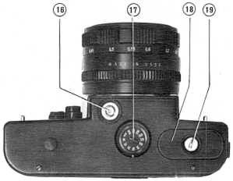
battery check window
battery check button
viewfinder eyepiece with mount for attaching photo accessories
back door lock
film plane index
sprocket
camera back door
