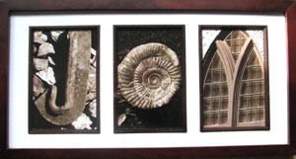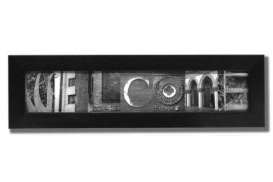
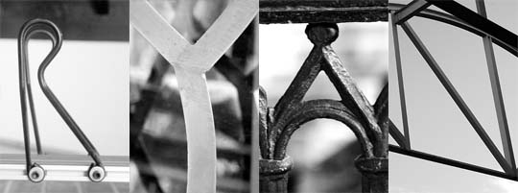
http://www.alpha26photography.com/aboutus.aspx
Need to spell at word at least 4 letters long! Make it fun! Take Multiple Pictures of each letter. Should reflect theme!

