5 or 10 Frame Storytelling

You objective is to tell 2 stories using 5 frames each or 1 story using 10.

Requirements:

* Not picture can be bigger than 2 in x 3 in
* Matted 3 inch boarder all the way around
* Story must be easily read
* Photo must be enhance in Photoshop (use filters, adjustments, color enhancements, blur objects, etc)

Draw inspiration at <http://5frame.ning.com/>

[](http://www.flickr.com/photos/adarlingfelicity/4456239324/)[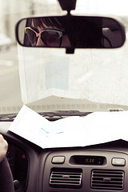](http://www.flickr.com/photos/adarlingfelicity/4456232416/)[](http://www.flickr.com/photos/adarlingfelicity/4456265432/)[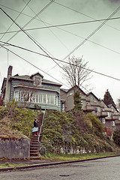](http://www.flickr.com/photos/adarlingfelicity/4453610074/)[](http://www.flickr.com/photos/adarlingfelicity/4455470655/)

|  |  |
| --- | --- |
| [moped by thetahna](http://www.flickr.com/photos/63863754@N00/4455467055/) |  |

[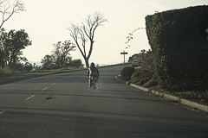](http://www.flickr.com/photos/63863754@N00/4455467933/)[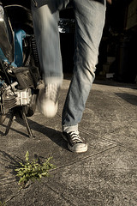](http://www.flickr.com/photos/63863754@N00/4456247480/)[](http://www.flickr.com/photos/63863754@N00/4456246736/)[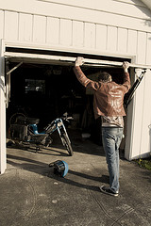](http://www.flickr.com/photos/63863754@N00/4456246598/)

